Electrostatic coating machine
（HXC-JD-A3）
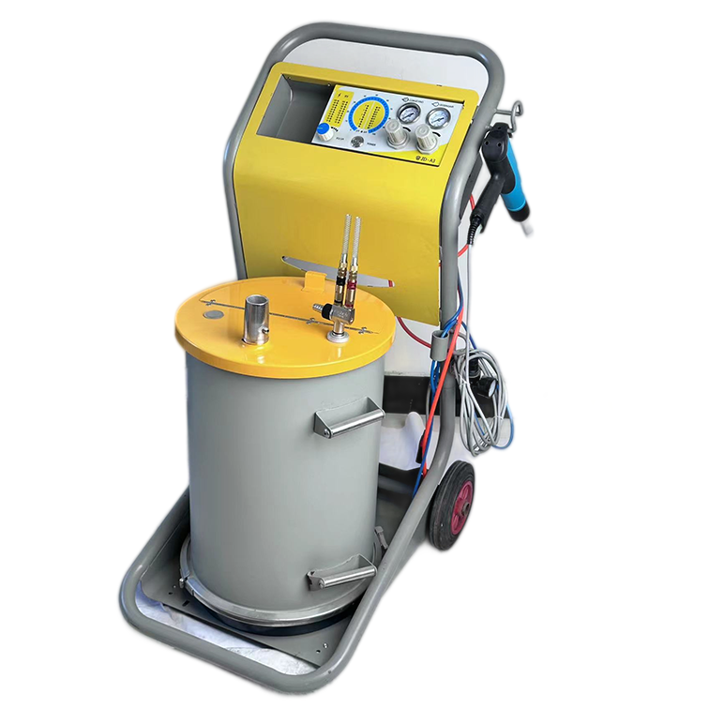

Hangzhou Huaxiang Coating Equipment Co.,Ltd.
No.13 Xitanghe Village, Liangzhu Town, Yuhang District, Hangzhou, Zhejiang, China

Catalogue

I. Overview ………………………………………………… (3)
2. Safety regulations …………………………………………… (3)
3.the composition of the manual single-gun system ……………………………… (3)
4. Main technical parameters ……………………………………… (3)
5. Operating instructions …………………………………………… (5)
① Preparation before starting ……………………………… (5)
② Turn on ……………………………………………… (6)
③ Shut down ……………………………………………… (6)
④ Change color ……………………………………………… (7)
6, cleaning and maintenance ………………………………………… (7)
7, fault check …………………………………………… (11)

I. Main features:
1, detachable voltage doubler close to the nozzle, low voltage loss.
2, novel and unique two central gas, constantly clean the central electrode, excellent discharge effect, high powder rate.
3, voltage, current LED display (digital display), easy to interpret.
4, intuitive barometer display, the operation is very convenient.
5, especially light and reasonable gun structure (gun weight 570), compact and beautiful, very contemporary.
6, a variety of nozzles to choose from, the size of the horn nozzle is the ideal choice for large plane workpiece powder.
7, stainless steel powder barrel luxury steam pie, clean and convenient.
2. Safety rules
1. Read carefully and observe the following safety precautions before starting the device; otherwise, it may cause danger.
2, conductive items within 5 meters of the coating area, especially the workpiece must be grounded.
3, the floor of the coating area must be an electrical conductor (general cement floor can conduct electricity)
4, the operator's shoes must be conductive materials (such as leather soles).
5, the operator should be unarmed gun, such as wearing gloves, its material should be electric conductor.
6, one end of the gun grounding wire should be connected to the spray room or other grounded equipment, grounding resistance ≤4Ω.
7, when the spray chamber recovery equipment is started, the switch of the spray gun control unit can be turned on. When the spray chamber recovery equipment fails, the control unit of the spray gun must be closed.
8. Check the grounding condition of all conductive items at least once a week.
9. When cleaning the spray gun and replacing the nozzle, the power supply of the control unit must be cut off.
3. Composition of manual single-gun system
1. 1 set of control unit
2, manual powder gun 1 set
3. 1 set of powder drum
4. Main technical parameters
1. Circuit (control unit)
Input voltage 220V
Frequency 50HZ\
Input power 30W
Output current max0.9A
Valve control voltage DC24V
Protection level Dynamic IP54
2. Gas path
Input air pressure 6 ~ 8KG
The maximum moisture content in the compressed air is 1.3g/m3
The maximum oil content in compressed air is 0.1ppm
Compressed air consumption 1.8m3/h
3. Gun body (high voltage generator in gun body)
Input voltage 0 to 12V
Power frequency 10KHZ
Output voltage 0 ~ 100KV
Maximum output current 0.15M
4. Equipment size
Length 450mm
The width is 560m
The height is 960mm
Weight 35kg
Powder cylinder size φ350×500mm
Volume weight ~ 50L (~ 25kg)
Face-plate

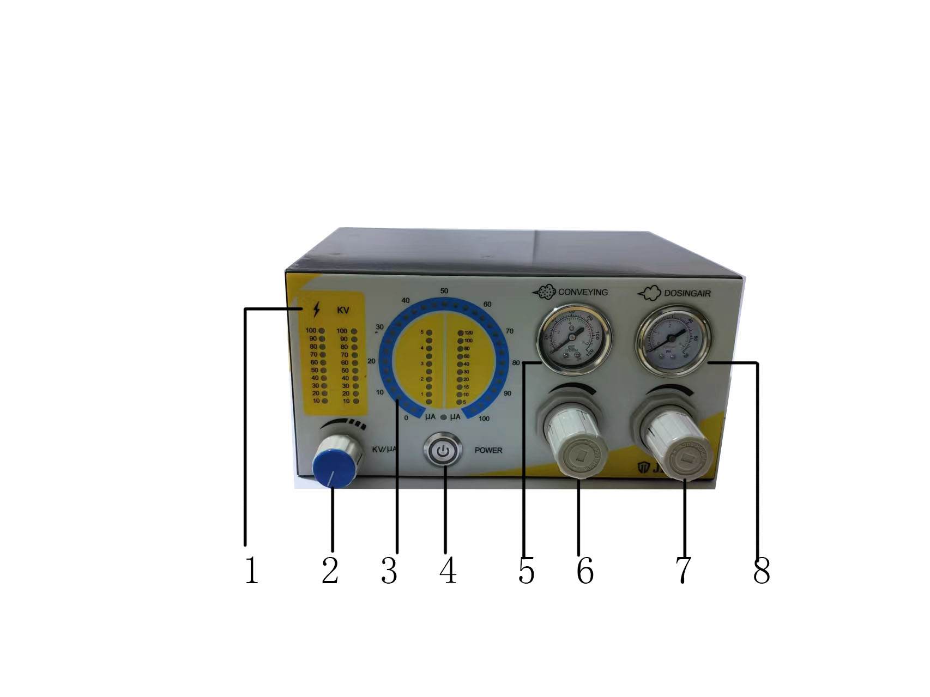
1. Voltage regulation indication
2. Voltage/current adjustment button
3. Current regulation indication
4. Power switch
5. Powder quantity indication
6. Powder output adjustment button (primary air button)
7. Powder output uniformity adjustment button (secondary air button)
8. Powder uniformity indicator

Rear panel

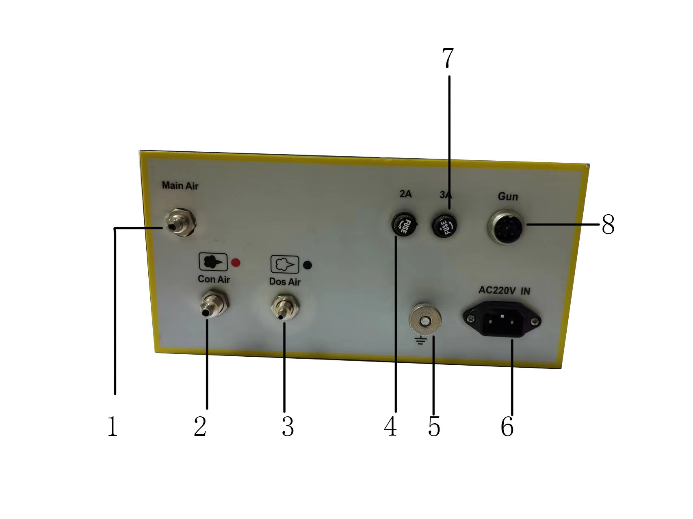

1. Main air intake connector
2. Primary air connector
3. Secondary air connector
4. Mainboard fuse
5. Ground cables for the control unit
6. Input the power socket
7. Power fuse
8. Gun power cable connector

Operation instructions

(1) Preparation before starting the machine
Composition of manual single-gun system
Most of the assembly of the single-gun system has been completed before leaving the factory, so it is only necessary to connect some lines .
2. Check whether all conductive materials within 5M of the coating room are grounded.
(2) Boot
1. Powder fluidization
The degree of powder fluidization depends on the type of powder, air temperature and ambient humidity. After the sprayer is started, the fluidized bed also works.
1.1 Open the lid of the powder drum
1.2 Adjust the fluidized air pressure regulating valve located on the right side of the column to slowly increase the fluidized air. At this time, the powder should be slightly and evenly "flowing". If necessary, the supply of fluidized air can be enhanced until the powder is normally "flowing" and then the amount of fluidized air can be reduced.
1.3 Cover the powder drum
2, adjust the amount of powder
2.1 Turn on the spray machine power switch (9)
2.2 Pick up the spray gun, point the muzzle towards the painting room and pull the trigger.
2.3 Set the air delivery
Adjust the conveying air pressure adjustment button (1) so that the pointer of the conveying air pressure gauge (2) is adjusted to 3kg
Adjust the subsidy (or secondary air) air. Adjust the subsidy (or secondary air) air
Adjust the auxiliary air pressure adjustment button (3), so that the needle of the conveying air pressure gauge (4) is adjusted to 0.5-1kg, so that the spray gun powder is adjusted evenly
3, adjust the gun output voltage
3.1 Point the gun towards the spray room (at this time, the muzzle does not point at the workpiece) and pull the trigger.
3.2 Adjust the high voltage/current adjustment button (8), and pay attention to the voltage display, under normal circumstances, the LED display voltage setting/reading (7) can be adjusted to about 60KV.
4. start spraying the workpiece
(3) Shut down
1, loosen the gun trigger, high pressure automatically cut off, powder stop.
2. Turn off the movie switch of the control unit (9).
3, close the compressed air, at this time the fluidized air source is cut off.
(4) Change colors
1. Turn off the control unit and fluidized gas. .
2. Pour out the powder in the powder cylinder and clean it up.
3. Use pure compressed air to blow the powder pipe clean.
If you use a sponge latex (diameter of about 15mm) to blow it from one end of the tube to the other end, the powder tube can be easily cleaned.
4. Clean the Venturi powder pump with pure compressed air.
5. Disassemble and clean the spray gun (with pure compressed air).
6. When painting new powder, spray a small amount of new powder first to "wash" the powder tube and spray gun.
Cleaning and maintenance
Regular maintenance can extend the service life of the painting equipment, and maintain the uniform and stable quality of the painting for a long time.
Daily maintenance work
1. Clean Venturi powder pump (see relevant section of this article).
2. Clean the gun (see the relevant section of this article).
3. Clean the powder cartridge (see the relevant section of this article).
Weekly maintenance work
1. Clean the powder drum, Venturi powder pump and spray gun, and do not pour powder before the next painting job.
2. Check the grounding condition between the control unit, painting room, sling or conveying device.
(c) if the control unit will not be used for several days
1. Remove the power plug.
2. Clear the controller.
3. Remove the compressed air supply connected to the control unit.
1. Clean the powder cartridge
2. Pull out the gas supply pc tube (blue tube) of the fluidized bed and remove the grounding wire.
3. Remove the lower Churi powder pump and clean the extraction pipe connected with the powder pump.
4. Remove the lid and wipe it with a clean dry brush and cloth.
5. Pour the residue into another container.
6. Clean the barrel, especially the fluidized-bed part.
7. Wipe the bucket clean with a clean dry cloth.
8. Reassemble the powder bucket.
Note: Do not pour the powder into the powder barrel before the next painting job, and do not clean the fluidized bed with solvents or water.
1. All the gas lines in the system are equipped with quick connectors. When disassembling the gas pipe, press the pressure ring of the pipeline quick connector backward with your thumbnail to pull out the plastic gas pipe. Simply press the plastic air pipe into the quick fitting for assembly.
(5) Clean the spray gun
To ensure the quality of the coating, clean the gun frequently.
Attention! Before cleaning, turn off the control unit switch and unplug the gun power socket from the unit backplane (4). The compressed air used must not contain oil, gas and water.
1. Clean the outside of the gun (daily)
2. Remove the powder pipe (weekly).
3. Remove the nozzle from the gun and clean it.
4. Compressed air is blown through the inlet of the powder to purify its interior.
5. Blow the gun clean with compressed air.
6. Clean the powder pipe.
7. Reassemble the gun.
(6) Decomposition of spray gun
Attention! Disassembly of the gun is only necessary unless the gun is malfunctioned or defaced internally. Only relevant parts that must be removed can be disassembled.

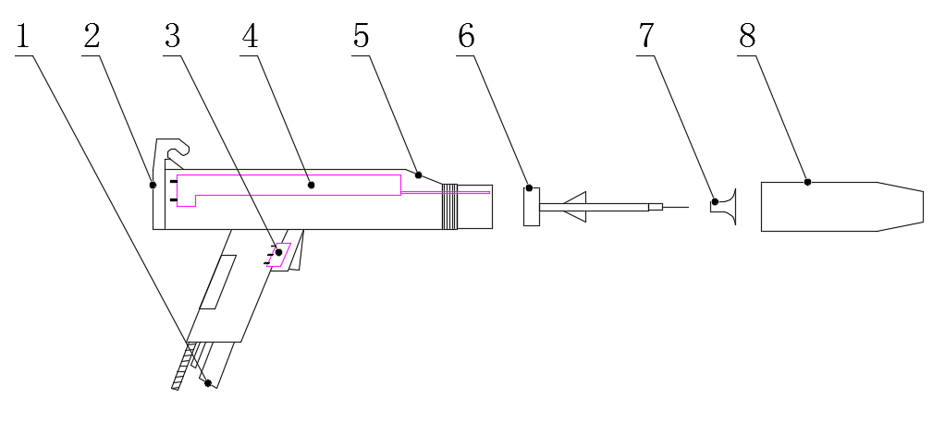
图号 | 名称 | QTY(pcs) | 备注
1 | Powder pipe | 1
2 | Rear cover | 1
3 | Gun switch | 1
4 | High voltage module | 1
5 | Gun body | 1
6 | Deflector rod | 1
7 | Diffuser screen | 1
8 | Gun cap | 1

1. Close the control unit and remove the gun before cleaning.
2. Do not disassemble the high pressure doubler (doubler block), because this part has been specially processed and manufactured, so there is a fault in this part, please send all the gun body back to our after-sales service department.
3. Unless the damaged parts are replaced, almost no repair work is required. As for the replacement of the high voltage doubler and the cleaning of the gun circuit connector, it must be carried out by the officially authorized service center.

七、Failure checking
Symptom Possible cause Solution | fault cause | Solutions
A, turn on the power switch, the circuit board power indicator is off | A1, no power, or the power cable is bad  A2, the fuse or transformer is broken  A3. The circuit board is damaged  A4, the circuit board slot is not inserted into | A1, the power supply is connected, or the power cable is replaced  A2, replace the fuse or transformer  A3. Replace the circuit board  A4, connect the cable trough
B, there is a power supply indication, but the trigger gun switch has no electrostatic display, and the gun head does not come out. | B1, gun switch is broken  B2, gun cable is not connected or damaged  B3, the circuit board is damaged | B1, replace  B2. Connect the cable or replace it  B3, replacement
C, there is a power supply indication, the trigger gun switch has powder without static electricity. | C1. Circuit board is damaged  C2, gun high pressure block damaged | C1, replace  C2, replacement
D, there is a power supply indication, the trigger gun switch has static electricity, no gas out of the gun head. | D1, if the generator can not hear the solenoid valve working "click" sound may: ① the input air pressure is too high (has been higher than 8kg) ② the solenoid valve is damaged D2, if the "click" sound is heard in the generator, it may be: ① the primary gas pressure regulator is not opened or the pressure regulator is damaged ② the powder pipe is not connected ③ the powder pump is not connected | D1. Lower the air pump pressure or replace the solenoid valve  D2. ① Open or replace the pressure regulator  ② Connect the powder supply pipe  ③ Connect the powder pump
E, there is a power supply indication, there is static electricity in the trigger gun switch, and there is no powder out of the gun head | E1, powder pump lining sleeve worn or blocked  E2, secondary air regulation is too large, primary air regulation is too small E3, the two gas pipes on the powder pump are connected to the reverse | E1, and the powder pump is replaced or cleaned E2, adjust the primary gas, reduce the secondary gas  E3 Reconnect
F, uneven powder production | F1, powder pump powder nozzle wear  F2, did not adjust the secondary gas | F1, replace the powder nozzle  F2, adjust the secondary gas clockwise

