华祥涂装

HXC-600A-双调手动喷枪使用
说明书
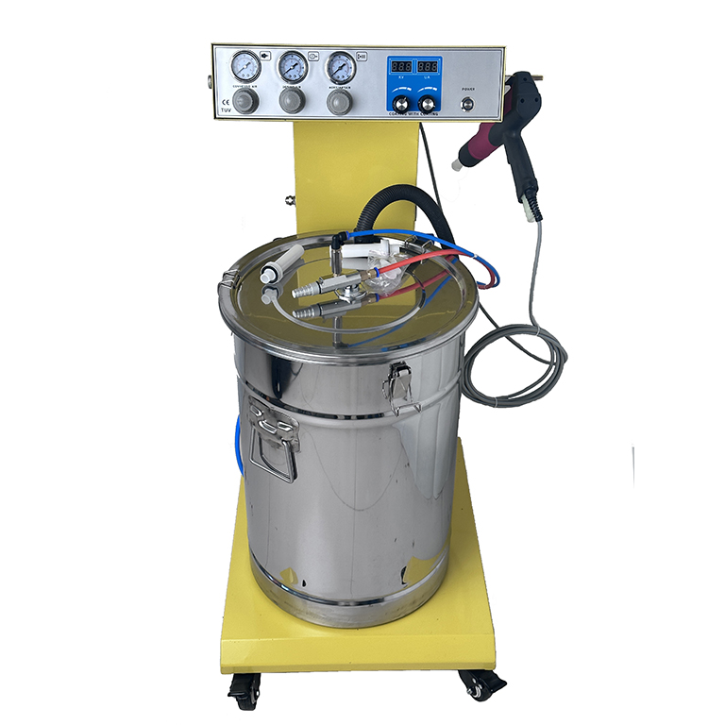

杭州华祥涂装设备有限公司

HangZhou HuaXiang Coating Equipinent Co ltd
地址：杭州市余杭区良渚镇西塘河村

目 录

- 概述…………………………………………………（3）
- 安全规则……………………………………………（3）
- 手动单枪系统之组成………………………………（3）
- 主要技术参数………………………………………（3）
- 操作说明……………………………………………（5）
- 开机前的准备工作………………………………（5）
- 开机………………………………………………（6）
- 关机………………………………………………（6）
- 换色………………………………………………（7）
- 清洁与保养…………………………………………（7）
- 故障检查 ……………………………………………（10）

- 主要特点Main Features：
- 可拆卸之倍压器紧邻喷嘴，电压损耗低。
Detachable voltage multiplier adjacent to nozzle, low voltage loss.
- 新颖独特的两路中央气，不断清理中央电极，放电效果优，上粉率高。
Novel and unique two-way central gas, continuously cleaning the central electrode, the discharge effect is excellent, the powder rate is high.
- 电压、电流LED显示（数显），易于判读。
Voltage, current LED display (digital display), easy to read.
- 直观的气压表显示，操作极为方便。
Intuitive barometer display, operation is extremely convenient.
- 特别轻便合理的枪体结构（枪重570），紧凑美观，极富时代感。
Especially light and reasonable gun body structure (gun weight 570), compact and beautiful, extremely modern sense.
- 多款喷嘴可供选择，大小不一的喇叭型嘴是大平面工件喷粉的理想选择。
A variety of nozzles can be selected, the size of the horn nozzle is the ideal choice of large-plane workpiece powder injection.
- 不锈钢粉桶豪华汽派，清洁便利快捷。
Stainless steel powder barrel luxury steam pie, clean, convenient and fast.

- 安全规则
- 开启设备前必须认真阅读并遵守以下安全事项，否则可能造成危险。
Read and observe the following safety precautions carefully before turning on the equipment, otherwise it may be dangerous.
- 在涂装作业区5米范围内的扬有导电物品，特别是工件必需接地。
In the painting area within 5 meters of conductive materials, especially the work piece must be grounded.
- 涂装区的地板必须为电导体（一般水泥地面即能导电）
The floor of the coating area must be an electrical conductor (general cement floor can conduct electricity)
- 操作人员所穿鞋子必须为导电材料（如皮制鞋底）。
The operator must wear shoes of conductive material (e.g. leather soles).
- 操作人员应赤手持枪，如戴手套其材质应为电导体。
Operators should be bare- handed gun, such as gloves should be made of electrical conductors
- 喷枪接地线的一端应接到喷房或其它已接地的设备上，接地电阻≤4Ω。
One end of the spray gun ground wire should be connected to the spray room or other earthing equipment with a grounding resistance ≤ 4 Ω.
- 当喷室回收设备启动后方可打开喷枪控制单位之开关，当喷室回收设备出现故障时必须关闭喷枪之控制单元。
The spray gun control unit must be turned off when the spray chamber recovery equipment is activated, and the spray gun control unit must be closed when the spray chamber recovery equipment fails.
- 每周至少一次检测查所有导电物品之接地情况。
Check at least once a week for grounding of all conductive items.
- 清理喷枪更换喷嘴时，必须切断控制单元的电源。
When cleaning the spray gun to replace the nozzle, the power supply of the control unit must be cut off. .

- 手动单枪系统之组成
- 控制单元 1套
Control unit 1set
- 手动喷粉枪 1套
Manual powder gun 1set
- 粉桶 1套
Powder barrel 1set

四、主要技术参数
1、电路（控制单元）Circuit (control unit)
输入电压 220V
Input voltage
频率 50HZ\
Frequency
输入功率 30W
Input power
输出电流 max0.9A
Output current
阀控电压 DC24V
Valve-controlled voltage
保护等级动性 IP54
Protective level dynamic
2、气路 gas path
输入气压 6～8KG
Input pressure
压缩空气中最大水气含量 1.3g/m³
Maximum moisture content in compressed air
压缩空气中最大油份含量 0.1ppm
Maximum oil content in compressed air
压缩空气耗量 1.8m³/h
Compressed air consumption
3、枪体(枪体内置高压发生器)gun body (gun body built-in high voltage generator)
输入电压 0～12V
Input voltage
电源频率 10KHZ
Power frequency
输出电压 0～100KV
Output voltage
最大输出电流 0.15Ma
Maximum output current
4、设备尺寸equipment size
长450mm
Long
宽560mm
Wide
高960mm
Height
重量35kg
Weight
粉筒规格φ350×500mm
Powder cylinder specification
容重～50L（～25kg）
Bulk density

面板Face-plate

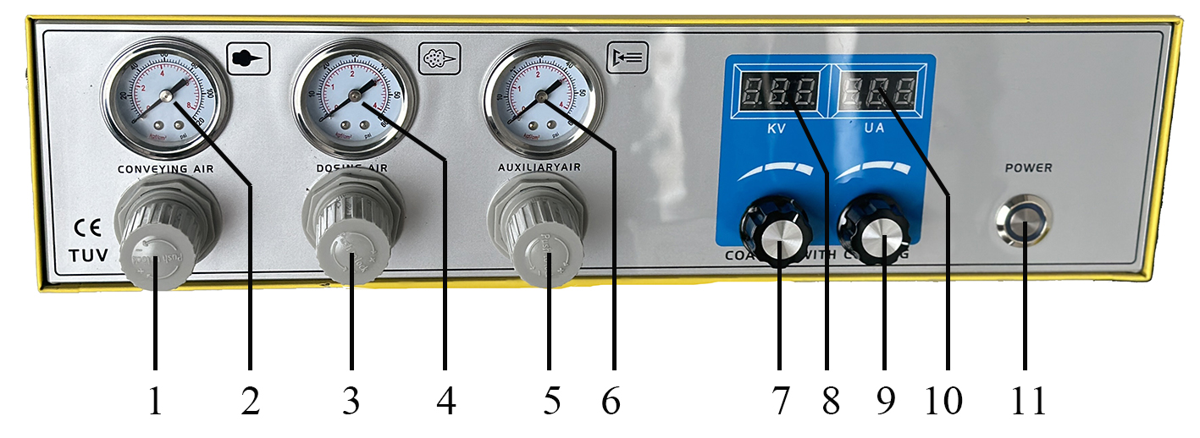
- 出粉量大小调节（顺时针大）Adjust the amount of powder produced (large clockwise)
2、出粉大小压力指示Powder size pressure indicator
3、出粉均匀度调节阀（逆时针小）Powder uniformity regulator (small counterclockwise)
4、二次气大小指示Secondary gas indication
5、三次空气压力调节钮（逆时针小）Triple air pressure regulator (small counterclockwise)
6、三次空气流量计Cubic air Flowmeter
7、电压高低调节High and low voltage regulation
8、电压大小显示 Voltage size display
9、电流高低调节High and low current regulation
10、电流大小显示 Current size display
11、电源开关（顺时针开，逆时针关）Power switch (open clockwise, turn counterclockwise)

背板Rear panel

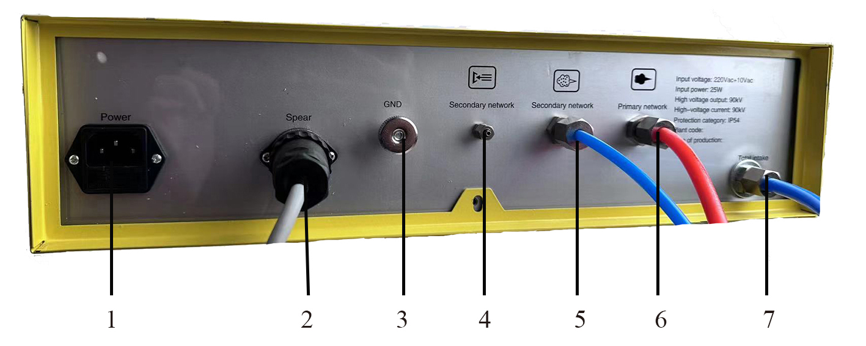
- 输入电源插座Input powder outlet
- 喷枪电源插座Spray gun power outlet
- 控制单元接地线接头Control unit ground connection
- 三次风接头（￠4）Third air connection（￠4）
- 二次风接头（￠6） Second air connection（￠4）
- 输送空气接头（￠8）output air connector（￠8）
- 输入空气接头（￠8）Input air connector（￠8）

五、操作说明Operational instructions
（一）、开机前的准备工作 Preparation before boot
手动单枪系统之组成Composition of manual single gun system
该单枪系统在出厂前已完成大部分的组装工作，故只需按下列步骤将某些管线接上即可。
The single gun system has completed most of the assembly work before leaving the factory, so just follow the following steps to connect some pipelines.

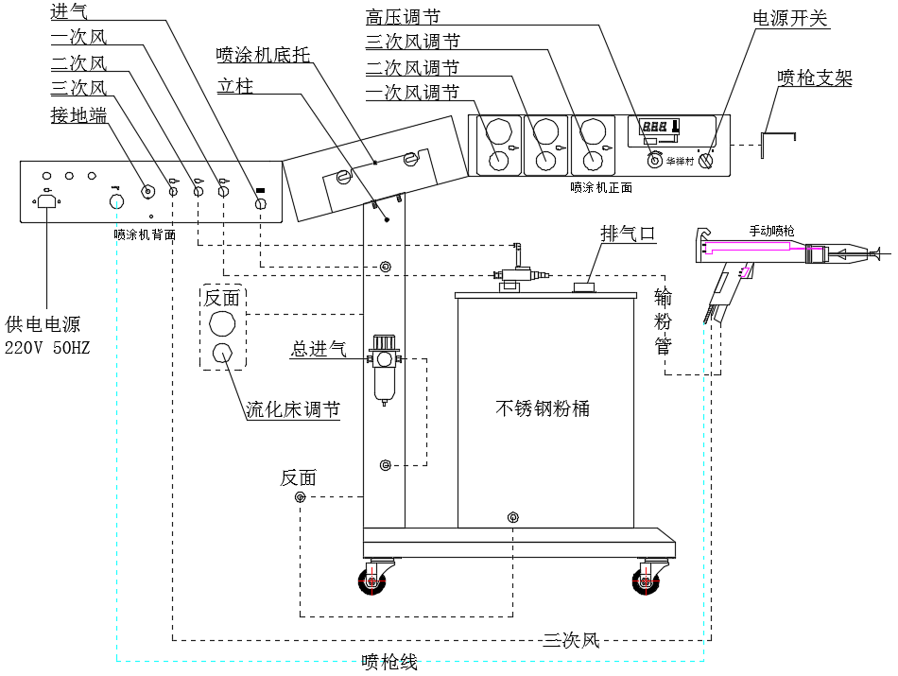
1.1将喷涂机底托用螺丝与立柱固定，喷涂机放置在底托上，同时右侧将喷枪支架夹在里面在通过铜螺帽固定。
Fix the sprayer bottom bracket with the screw and place the sprayer on the bottom bracket. At the same time, clamp the gun bracket on the right side and fix it through the copper nut.
1.2喷枪装于喷涂机右侧枪架上，供粉筒置于车架的底板上。
The spray gun is mounted on the gun frame on the right side of the sprayer, and the powder cartridge is placed on the bottom plate of the frame.
1.3将外接压缩空气进气管接至立柱上的进气过滤杯上，出口与立柱左侧下面快接相连。
Connect the external compressed air intake pipe to the intake filter cup on the column, and the outlet is connected to the left side of the column.
1.4将立柱上端侧面快速接头与喷涂机背板输送空气接头（10）通过气管连上，背板输送空气接头（9）与文丘里（3）相连。
Connect the upper side quick joint of the column to the sprayer back plate conveying air joint (10) through the air pipe, and the back plate conveying air joint (9) is connected with the venturi (3).
1.5将背板补助空气接头（8）与文丘里粉泵二次风快速接头（1）相连。
Connect the back plate auxiliary air connector (8) to the venturi powder pump secondary air quick connector (1).
1.6将已接于发生器立柱下色流化床空气管的另一端接至粉筒左下部流化床“L”型接头上。
Connect the other end of the fluidized bed air tube that has been connected to the generator column to the “L” type joint on the left lower fluidized bed of the powder cylinder.

1.7将喷枪上三次风空气管另一端接至喷涂机背板三次风接头（7）上。
Connect the other end of the third air duct on the spray gun to the third air connection (7) of the sprayer back plate.
1.8将喷枪上粉管接至文丘里泵粉嘴（7）上。
Connect the powder tube on the spray gun to the venturi pump nozzle (7).
1.9将喷枪电缆上有3针式插头的一端插于喷涂机背板有喷枪标识的插座(5)上。
Insert one end of the gun cable with a 3-pin plug into the socket (5) on the back of the sprayer with the gun logo.
1.10将单枪系统黑色电源线分别接到喷涂机背板输入电源插座上及外部电源插座上。
Connect the black power cord of the single gun system to the input power socket of the sprayer backplane and the external power socket.
1.11将溢粉排气管(黑色蛇形软管)的一端接到粉筒上排气出口端套上,另一端置于喷粉室的开口处。
Connect one end of the overflowing exhaust pipe (black serpentine hose) to the exhaust outlet end sleeve of the powder cylinder, and the other end to the opening of the dusting chamber.
注意：操作时粉筒内压力不应调的太大已免将粉末溢出。
Note: The pressure inside the toner cartridge should not be adjusted too much during operation to avoid spilling the powder.
1.12将黄绿色接地线的两个触点分别接至控制单元背板接地端（6）及粉筒左下部接地端上，同时将接地线带有金属夹子的另一端接到已接地的喷粉室或其它已接地的设备上。
Connect the two contacts of the yellow-green grounding wire to the grounding end of the backplane of the control unit (6) and the grounding of the lower left side of the powder cylinder, and connect the other end of the grounding wire with the metal clip to the grounded dusting. Room or other grounded equipment.
- 单枪系统的设定工作电压为220V，如使用电压超过设定电压的上下限时，必须采用稳压电源。当使用电压高于设定电压10％时，内部组件更可能损坏；若使用电压低于设定电压15％时，喷枪将不能正常工作。
The set voltage of the single gun system is 220V. If the voltage exceeds the upper and lower limits of the set voltage, a regulated power supply must be used. When the operating voltage is 10% higher than the set voltage, the internal components are more likely to be damaged; if the operating voltage is lower than 15% of the set voltage, the gun will not work properly.
3．装填粉末 Filling powder
3.1将粉桶盖上的文丘里粉泵及溢粉排气筒向上拔出,打开粉桶盖上的肘肝扣锁并拿开粉筒盖(注意不可损坏了抽粉管)。
Pull out the venturi powder pump and the powder discharge vent on the powder drum cover, open the elbow lock on the powder bucket cover and remove the powder cover (be careful not to damage the powder pump).
3.2以粉筒把手为上限，倒入粉末（最多25kg）。
Take the powder handle as the upper limit and pour the powder (up to 25kg).
3.3小心把盖子装回并扣上肘肝杆扣锁，同时装上文丘里粉泵及溢粉排气管。
Carefully replace the cover and fasten the elbow lock, and install the above-mentioned churi powder pump and the powder exhaust pipe.
- 检查涂装室5M范围内所有导电物品是否已接地。
Check that all conductive items within the 5M range of the paint booth are grounded.
（二）、 开机Starting up
1、粉末流化 powder fluidization
粉末流化的程度视粉末种类，空气温度及环境湿度而定。在喷涂机启动后，流化床也随之工作。
The degree of fluidization of the powder depends on the type of powder, air temperature and ambient humidity. The fluidized bed also works after the sprayer is started.
1.1打开粉桶盖 Open the barrel cover
1.2调整位于立柱右侧的流化空气压力调节阀,慢慢增加流化空气,此时粉末应轻微而均匀地“流动”，必要时可增强流化空气之供应，直至粉末正常“流动”后再减少流化空气量。
Adjust the fluidizing air pressure regulating valve located on the right side of the column to slowly increase the fluidizing air. At this time, the powder should be “flowed” slightly and evenly. If necessary, the supply of fluidized air can be enhanced until the powder “flows” normally. Reduce the amount of fluidized air.
1.3盖上粉桶盖cover the powder hopper cover
2、调整出粉量adjust the amount of powder
2.1打开喷涂机电源开关（9） Turn on the sprayer power switch (9)
2.2拿起喷枪，枪口朝向涂装室内并扣动扳机。
Pick up the gun, the muzzle is facing the painting room and the trigger is pulled.
2.3设定输送空气setting the conveying air
调整输送空气压力调节钮（1），使输送空气压力表（2）的指针调至3kg
Adjust the delivery air pressure adjustment knob (1) to adjust the pointer of the air supply pressure gauge (2) to 3kg.
2.4调整补助（或称二次风）空气Adjust the subsidy (or secondary air) air
调整补助空气压力调节钮（3），使输送空气压力表（4）的指针调至0.5-1kg，让喷枪出粉调至均匀
Adjust the auxiliary air pressure adjustment knob (3) so that the pointer of the air pressure gauge (4) is adjusted to 0.5-1kg, so that the spray gun is evenly adjusted.
3、调整喷枪输出电压Adjust the output voltage of the spray gun
3.1将喷枪朝向喷涂室内（此时枪口勿对着工件）并扣动扳机。
Point the spray gun toward the spray booth (the gun is not facing the workpiece at this time) and pull the trigger.
3.2调整高电压/电流调整钮（8），并注意观察电压显示，一般情况下可将LED显示的电压设定/读数（7）调至60KV左右。
Adjust the high voltage / current adjustment button (8), and pay attention to observe the voltage display. Under normal circumstances, the voltage setting/reading (7) of the LED display can be adjusted to about 60KV.

4、开始对工件进行喷涂start spraying the workpiece
（三）关机shutdown
1、松开喷枪扳机，高压自动切断，喷粉停止。
Release the gun trigger, the high pressure is automatically cut off, and the powder is stopped.
2、关闭控制单元电影开关（9）。Turn off the control unit movie switch (9).
3、关闭压缩空气，此时流化气源被切断。
Turn off the compressed air, at which point the fluidized gas source is cut off.
（四）换色color change
1、关闭控制单元和流化气。Turn off the control unit and fluidizing gas.
2、倒出粉筒内的粉末并将之清理干净。 Pour out the powder in the powder cylinder and clean it up.
3、使用纯净压缩空气将输粉管吹净。 Blow the powder tube with pure compressed air.
如使用海绵乳胶（直径约15mm）将之自管的一端吹至另一端，便可很容易将粉管清干净。
If you use a sponge latex (about 15mm in diameter) to blow it from one end of the tube to the other, you can easily clean the powder tube.
4、用纯净压缩空气清理文丘粉泵。Clean the wenqiu powder pump with pure compressed air.
5、分解并清理喷枪（用纯净压缩空气）。Decompose and clean the gun (with pure compressed air).
6、开始涂装新粉时，先喷出少量新粉以“冲刷”粉管及喷枪。
When starting to apply new powder, first spray a small amount of new powder to “wash” the powder tube and spray gun.
六、清洁与保养Cleaning and maintenance
定期的维护保养即可延长涂装设备的使用寿命，又可长期维护涂装品质的均匀稳定。
Regular maintenance can prolong the service life of painting equipment and maintain uniform and stable coating quality.

  - 每天的维护保养工作Daily maintenance work
- 清理文丘里粉泵（参看本条相关部分）。
Clean up the Venturi powder pump (see the relevant section of this article).

- 清理喷枪（参看本条相关部分）。
Cleaning gun (see the relevant part of this article).

- 清理粉筒（参看本条相关部分）。
Cleaning cartridges (see relevant part of this regulation)

  - 每周的维护保养工作Weekly maintenance work
- 清理粉桶、文丘里粉泵及喷枪，在下次涂装作业前不可再倒入粉末。
Clean the powder barrel, Venturi powder pump and spray gun. Do not pour the powder before the next coating operation.

- 检查控制单元，涂装室，吊具或输送装置间的接地情形。
Check grounding between control units, coating rooms, hoists or conveyors.

  - 如果控制单元将有数天不使用时
If the control unit will not be used for several days
- 拔下电源插头。
Unplug the power supply.
- 清理控制器。
Cleaning controller.
- 拆下接在控制单元上的压缩空气供应。
Remove compressed air supply attached to control unit.
  - 清洁粉筒Clean powder barrel
- 拔下流化床之供气pc管（蓝色管），拆下接地线。
Unplug the pc tube (blue tube) and remove the ground wire from the fluidized bed.
- 拆下文丘里粉泵并清理与粉泵连接的抽取管。
Remove Venturi powder pump and clean the extraction pipe connected to the powder pump.
- 取下粉筒盖并用洁净的干刷子及抹布拭净之。
Remove the toner cover and clean it with a clean dry brush and rag.

- 将桶内残余倒入另一容器中。Pour the residue in the barrel into another container.

- 将桶内清理干净，特别是流化床部分。Clean the barrel, especially the fluidized bed.

- 用洁净的干抹布将桶擦干净。Clean the bucket with a clean dry rag.

- 重新组装好粉桶。Reassemble the powder barrel.

注意：Attention
- 下次涂装作业前不可将粉末倒入粉桶中，亦不可以溶剂或水来清洗流化床。
Do not pour powder into powder drum before next coating, nor can you clean fluidized bed with solvent or water.
- 本系统气路部分均使用了快速接头，拆卸气管时用大拇指指甲将管线快速接头的压环向后压， 便可拔出塑料气管。组装时只需将塑料气管压入快速接头内即可。
In this system, the quick joint is used in the air path, and the plastic pipe can be pulled out by using thumbnail to press the quick joint back when removing the trachea. When assembling, just press the plastic pipe into the quick joint.
（五）清洁喷枪Clean spray gun
为确保涂装质量，请经常将喷枪清理干净。
To ensure the quality of the coating, please often clean the spray gun.

注意！清理前，须先关闭控制单元开关并拔下单元背板（4）喷枪电源插座上的插头。使用之压缩空气不可含有油气和水份。
Be careful Before cleaning, the control unit switch must be closed and the plug on the unit back panel (4) on the power outlet of the gun should be unplugged. Compressed air in use must not contain oil, gas and water.

1.清理喷枪外部（每天）Cleaning the outside of the gun (everyday)
2.拆下输粉管（每周）。 Remove powder pipe (weekly).
3.拆下喷枪上喷嘴并清理。Remove the nozzle from the gun and clean it up.
4．将压缩空气从粉末入口处吹人以清净其内部。
Blow compressed air from the powder entrance to clean its interior.
5.用压缩空气将喷枪吹净。 Blow the gun clean with compressed air.
6.清理输粉管。 Clean the powder pipe.
7.将喷枪重新组装好。Reassemble the gun.
（六）喷枪之分解Spray gun decomposition
注意！除非喷枪内部故障或污损才有必要分解喷枪。只可分解相关而必须拆下的零件。
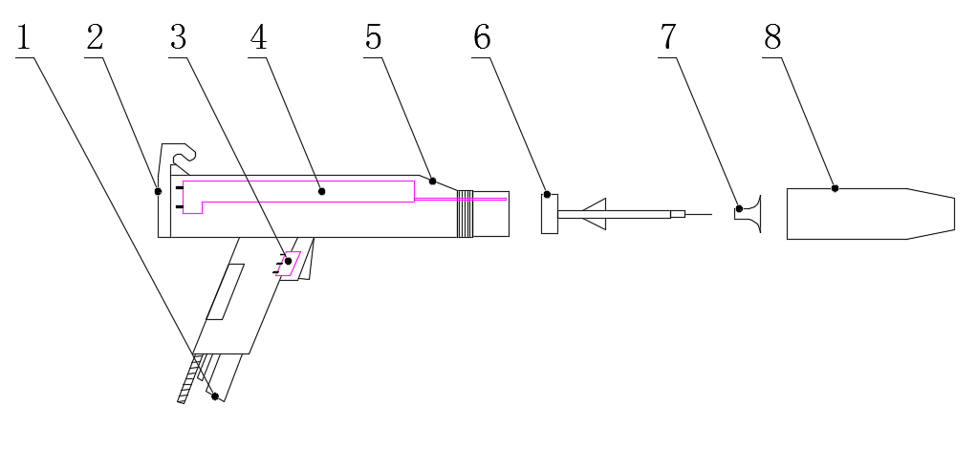
Be careful. It is only necessary to disassemble the spray gun unless there is an internal fault or stain. Only parts that must be disassembled because they are related to each other.

图号 | 名称 | 数量 | 单位 | 备注
1 | 进粉管 | 1 | 只
2 | 后盖 | 1 | 只
3 | 枪开关 | 1 | 只
4 | 高压模块 | 1 | 只
5 | 枪身 | 1 | 只
6 | 导流杆 | 1 | 只
7 | 扩散屏 | 1 | 只
8 | 枪帽 | 1 | 只

- 在清理前先关闭控制单元并拆下喷枪。
Close the control unit and remove the spray gun before cleaning.

- 不可拆解高压倍压器（倍压块），因该部分经特殊加工制造，如此部分确有故障，请将枪体全部寄回我公司售后服务部。
High pressure multiplier (double pressure block) can not be disassembled, because this part is made by special processing and such part is malfunction, please send all the guns back to our after-sales service department.

- 除非更换损坏零件，几乎不需任何修理工作，至于高压倍压器之更换及喷枪电路接头之清理，则须由正式授权之服务中心来执行请向我公司服务部洽询。
No repair work is required unless the damaged parts are replaced. For the replacement of the high pressure multiplier and the cleaning of the spray gun connection, please contact our service department for execution by a duly authorized service center.

（七）清洁文丘里粉泵Clean Venturi powder pump
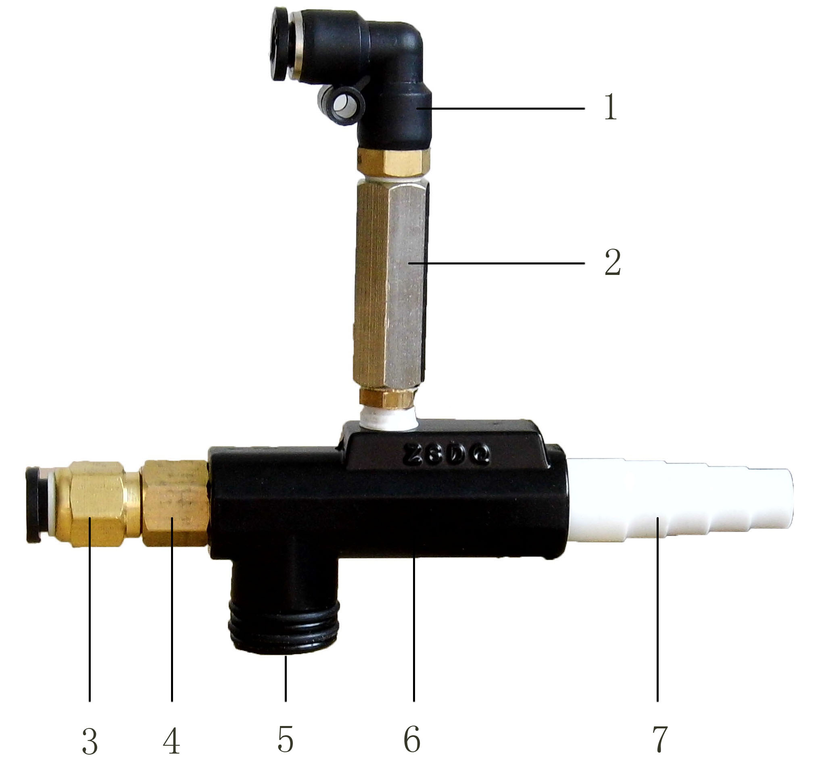
- 二次风快速接头
Secondary air fast joint
- 气路单向阀
Pneumatic one-way valve
- 输入空气之快速接头
Fast joint for air input
- 输入空气喷嘴
Input air nozzle
- 文丘里泵吸粉口
Venturi pump suction port
- 文丘里泵体
Venturi pump body
- 输粉管接头（粉嘴）
Powder pipe connection (powder nozzle)
A．清洁程序Cleaning procedure
1.将文丘里粉泵从粉桶盖上拆下。Remove the Venturi powder pump from the powder barrel cover.
2.拔掉输粉管接头（7）上的输粉管。
Unplug the powder conveying pipe on the powder conveying pipe joint (7).
3.拧下输粉管接头（7）Unscrew Powder conveying Pipe Connector (7)
4.使用不含任何油气水份得压缩空气，清理输粉管接头（7）及输粉管。
Use no oil and gas to compress the air, clean the powder pipe connection (7) and the powder pipe.
5.清理输粉管接头（7）时，清理并检查内壁是否已磨损。
When cleaning the powder conveying connection (7), clean and check if the inner wall is worn.
- 使用不含油气水分的压缩空气，清理文丘里泵体（6），经文丘里泵吸粉口（5）的开口即可看出有污染情形。
Using compressed air without oil and gas moisture, cleaning Venturi pump body (6), through the Venturi pump suction opening (5), you can see the pollution situation.
- 组合文丘里粉泵并将之装在粉桶盖上。
Combine Venturi powder pump and install it on the powder barrel cover.
注意！如果文丘里粉泵有严重污染情形，必须将之细部分分解（如上图），使用适当尺寸大小的扳手拆卸文丘里粉泵输入空气喷嘴，以不含油气水份的压缩空气将所有组件清理干净。绝不可以磨括，也不可以丙酮。
Be careful. If the Venturi powder pump is seriously contaminated, the fine parts must be decomposed (as shown above). Remove the Venturi pump air nozzle with a wrench of appropriate size and clean all components with compressed air without moisture. Never grind, nor do you use acetone.

- 拧下输粉管接头（7）并更换之。
Unscrew the powder conveying pipe joint (7) and replace it.

- 将新的粉嘴（7）插进文丘里泵体中，拧紧粉嘴，必须确定粉嘴是否与文丘里泵体紧密结合。Insert the new powder nozzle (7) into the Venturi pump body, tighten the powder nozzle, must determine whether the powder nozzle is closely combined with the Venturi pump body.

七、故障检查Failure checking
故障现象 | 故障原因 | 解决办法
A、打开电源开关，线路板电源指示灯不亮 | A1、未通电或电源线坏  A2、保险丝坏或变压器坏  A3、线路板损坏  A4、线路板线槽未插好 | A1、接通电源或更换电源线  A2、换保险丝或变压器  A3、更换线路板  A4、接好线槽
B、有电源指示，但扣动喷枪开关无静电显示，同时枪头没有气出来。 | B1、喷枪开关坏  B2、枪电缆未接好或损坏  B3、线路板损坏 | B1、更换  B2、接好电缆或更换  B3、更换
C、有电源指示，扣动喷枪开关有出粉无静电。 | C1、线路板损坏  C2、枪高压块损坏 | C1、更换  C2、更换
D、有电源指示，扣动喷枪开关有静电，没有气从枪头出来。 | D1、如发生器内听不到电磁阀工作的“咔嚓”声可能：①输入空气压力过高（已高过8kg）②电磁阀损坏  D2、如发生器内听到“咔嚓”声可能：①一次气调压阀未打开或调压阀损坏②粉管未接好③粉泵未接好 | D1、调低气泵气压或更换电磁阀  D2、①打开调压阀或更换调压阀  ②接好供粉管  ③接好粉泵
E、有电源指示，扣动喷枪开关有静电，枪头有气单没有粉末出来。 | E1、粉泵内衬套磨损或堵塞  E2、二次空气调节过大，一次气调节过小  E3、粉泵上两根气管接反 | E1、更换或清理粉泵  E2、调大一次气，调小二次气  E3重新接好
F、出粉不均匀 | F1、粉泵粉嘴磨损  F2、没有调整二次气 | F1、更换粉嘴  F2、顺时针方向调节二次气

